ATTACHMENT A

Incumbent Worker Project Funding Proposal

This agreement is between _______________________, and Workforce Tulsa. Both parties agree to the terms of this agreement as set forth below. Project is expected to commence on ___________________ and terminate on ___________________.
Project Lead

Contact Name: | Title:
Phone: | Email:
Business/Organization:
EMPLOYER INFORMATION

Legal Business Name:
Owner/Officer: | Phone:
Address:
Mailing Address (If different):
Employer Sector: Healthcare Manufacturing Transportation Construction Finance Other:
Is Employer expanding: YES NO | Length of time in business at this address:
Has the employer laid off workers within 120 days prior to relocation in OKLA from another state: YES NO
Employers FEIN #: | UBI #:
The employer is current in unemployment insurance and workers’ compensation taxes, penalties, and/or
interest or related payment plan: YES NO
Number of employees scheduled to participate in training:
Total number of employed by employer in state and nationally:
Is the company located in an area that gives preference as per OKLAHOMA WORKFORCE DEVELOPMENT ISSUANCE #09-2019?

What is the type of preference?
Provide a brief description of what is done at this location:
Project Overview

Description of Need:
List of Partners:
Project Timeline:
Will the Project Result in: Increased Employee Wages, Avert Future Layoffs, Other:

EMPLOYER RESPONSIBILITIES

- Provide the information below as required for employer and each employee participating in the approved project opportunity utilizing approved documentation.
- Agrees to work with Workforce Tulsa to identify and provide the employers process for complying with the required cost sharing requirements for this training, as determined by the size of the employer’s workforce. (Wages paid to the participant while in training can be included as part of that share and the share can be provided as cash or in-kind that is fairly evaluated and approved by Workforce Tulsa.
  - At least 10 percent of the cost for employers with 50 or fewer employees
  - At least 25 percent of the cost for employers with more than 50 employees but not more than 100 employees; and
  - At least 50 percent of the cost for employers with more than 100 employees
- Complete required close out report within 30 days of completion of training.
- Complete the following regarding the total cost of the program, including employer contribution:
Employer Cash: | Total Cost of Project:
Employee Wages: | Percentage Covered by Employer:
Employer In-Kind: | Total Requested from Board:
Total Employer Contribution: | Percentage Covered by Board:

Describe Employer Contribution:

Training Provider Justification

Training Provider:
Training Description:
Training Timeline:
Will training include local, state, or nationally recognized certificate? YES NO If so, list here:
Preferred Fiscal Contact for Training Provider: Project Lead Employer Workforce Tulsa
The selection made will be responsible for coordinating any fiscal payments with the training provider.
Required Project Documentation

Employer | Employee
- Employer Request Letter on Company Letterhead | - Employee Enrollment Form
- Project Funding Proposal, Attachment A | - Grievance & Complaint Procedures
- Final Project Report | - Photo ID
- IW Training Contract | - Consent for Sharing of Confidential Information
- Grantee Worksheet, attachment B  - Incumbent Worker Training Employee List, attachment C  - Anticipated Outcomes, attachment D  - Project Rating Form (Required if state money is requested), attachment E | - Form I-9, Employment Eligibility Verification  - OKJobMatch Account

Project Lead & EMPLOYER ASSURANCE

EQUAL OPPORTUNITY AND NONDISCRIMINATION STATEMENT: All Recipients, and Sub-

recipients/Sub-grantees must comply with WIOA’s Equal Opportunity and Nondiscrimination provisions which prohibit discrimination on the basis of race, color, religion, sex (including pregnancy, childbirth, and related medical conditions, transgender status, and gender identity), national origin (including limited English proficiency), age, disability, political affiliation or belief, or, for beneficiaries, applicants, and participants only, on the basis of citizenship status or participation in a WIOA Title-I financially assisted program or activity.

Project Lead: Employer – Owner/Designated Officer:

Print First/Last Print First/Last

Signature Signature

Date Date

This Incumbent Worker Training (IWT) opportunity is funded through the Workforce Innovation and Opportunity Act (WIOA) provided by the U.S. Department of Labor. This is a project led by the Tulsa Area Workforce Development Board.

ATTACHMENT B

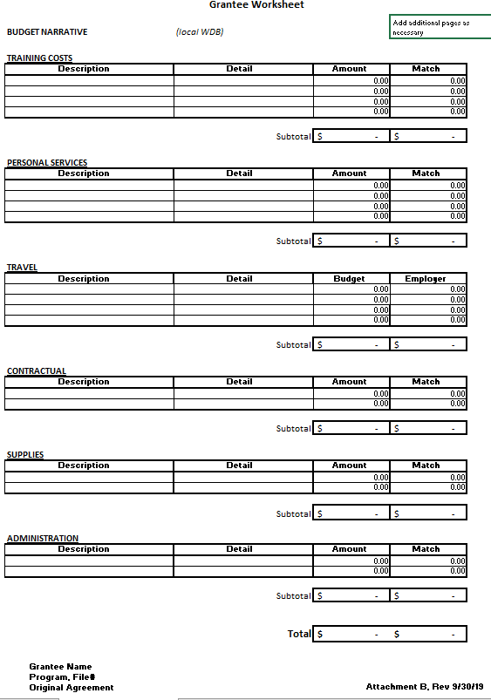

ATTACHMENT C

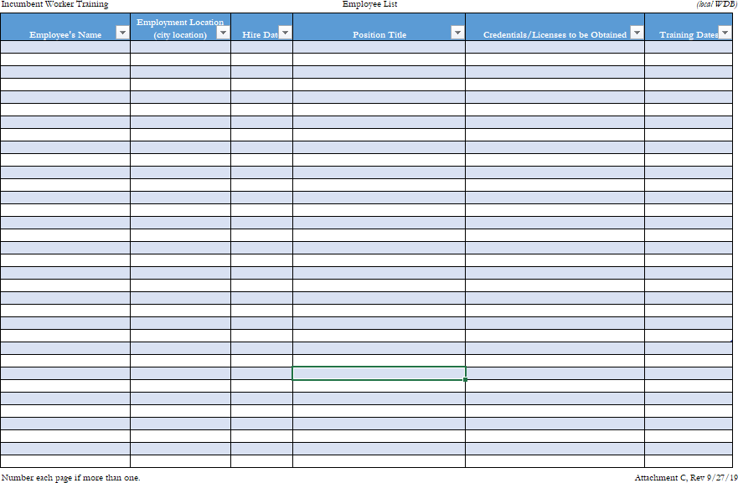

ATTACHMENT D

Employer:
Anticipated Outcomes of Incumbent Worker Training

Section 1. Check all that are applicable
- Will help prevent possible relocation of operations (layoff aversion)
- Will assist in the training of target groups or make employees more competitive
- Will contribute to the long term viability of our company
- Will be an important component of our company’s overall workforce development efforts, such as sector or career pathway strategy

- Will make this location more competitive

- Important to the stated mission of our company
- Will contribute to the short term viability of our company
- Will assist in the improvement of international trade opportunities

Section 2. At least six of the following ten must be completed

Will save jobs within the company

Will create new jobs within our company

Will lower turnover in our company by percent
Will Increase profit margin by percent over the next months

Will improve the long-term wage levels of trainees by percentage
Will create openings in entry-level positions Will improve unit or labor costs by percent
Will increase overall efficiency by percent Will increase or retain sales by percent over the next months
Will improve the short-term wage levels of trainees by percentage

Return on Investment Information
Planned ROI is expected to be percentage over months / years

ATTACHMENT E

Project Rating Form – Future of Work
APPLICANT:
Contact Name & Title:
County:
REVIEWER NAME:
REVIEW DATE:
Interview Questions:
Please rate project on the questions below. The scoring range goes from 0 – 5, 0 being the worst, 5 being the best. Please score the project and make any comments or notes needed.
1. What is the training? How many employees will attend? What is the duration? What is the requested funding? What is the company contribution? Who is the training entity? | Score:
Comments:
2. How will the training benefit the region, the employees, and the employer? Why is this training needed? Will it avert future layoffs or upskill employees to meet promotional requirements? | Score:
Comments:
3. Is the training and/or employer directly associated with one of the local/regional priority ecosystems (Healthcare, Energy, Manufacturing, Transportation, Construction or Finance? | Score
Comments:

4. Will the training include a nationally, regionally, or industry recognized certificate? | Score:
Comments:
5. Is the project aligned with an industry association partnership, such as an EDC, or other such business supported agency? | Score:
Comments:
6. Beyond the required in-kind/cash match, does the application for funds include additional funding to support the project? | Score:
Comments:
Reviewer signature: Date Overall Score: /30

Opportunity Zones
The following TAWDB census tracts are Designated Opportunity Zones as certified by the Secretary of the U.S. Treasury via his delegation of authority to the Internal Revenue Service (IRS). See IRS Notices 2018-48 https://www.irs.gov/pub/irs-drop/n-18-48.pdf

County Census Tract Number Tract Type
Creek 40037020102 Low-Income Community
Creek 40037021000 Low-Income Community
Osage 40113940002 Low-Income Community
Pawnee 40117957500 Low-Income Community
Tulsa 40143000100 Low-Income Community
Tulsa 40143000200 Low-Income Community
Tulsa 40143000900 Low-Income Community
Tulsa 40143001000 Low-Income Community
Tulsa 40143001200 Low-Income Community
Tulsa 40143002100 Low-Income Community
Tulsa 40143002301 Low-Income Community
Tulsa 40143002500 Low-Income Community
Tulsa 40143003400 Low-Income Community
Tulsa 40143004600 Low-Income Community
Tulsa 40143004900 Low-Income Community
Tulsa 40143005900 Low-Income Community
Tulsa 40143006200 Low-Income Community
Tulsa 40143006600 Low-Income Community
Tulsa 40143006801 Low-Income Community
Tulsa 40143007402 Low-Income Community
Tulsa 40143007608 Low-Income Community
Tulsa 40143008001 Low-Income Community
Tulsa 40143008002 Low-Income Community
Tulsa 40143009300 Low-Income Community
Tulsa 40143011100 Low-Income Community

